黎明國小 四年級英語學習單 ___年 ___班 座號：___ 姓名：__________

一、Read and Write 讀一讀，選出正確的提示
字填入句子中，完成對話
- 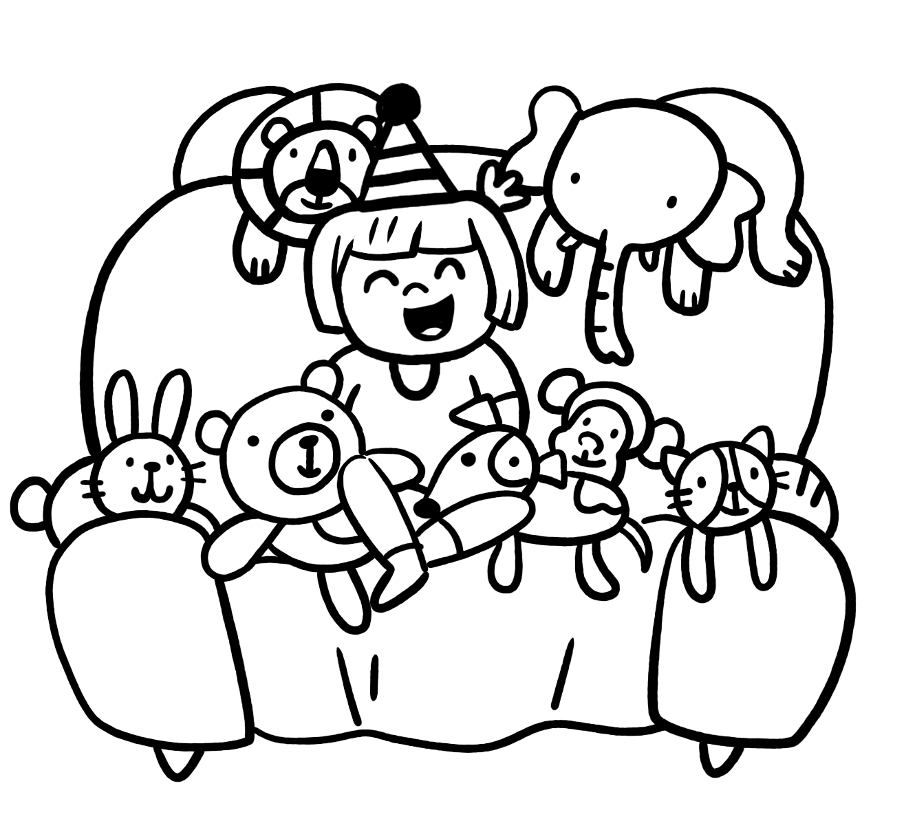
It’s / They’re / balls / dolls
A: What are those?
B: 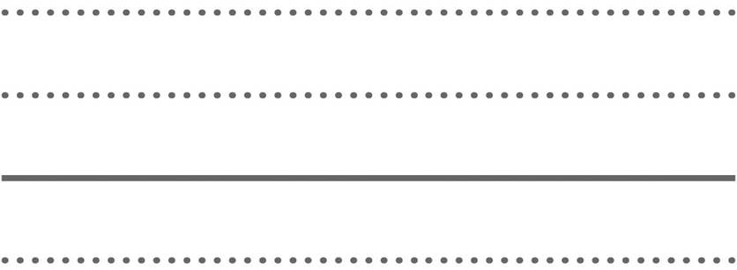 my .

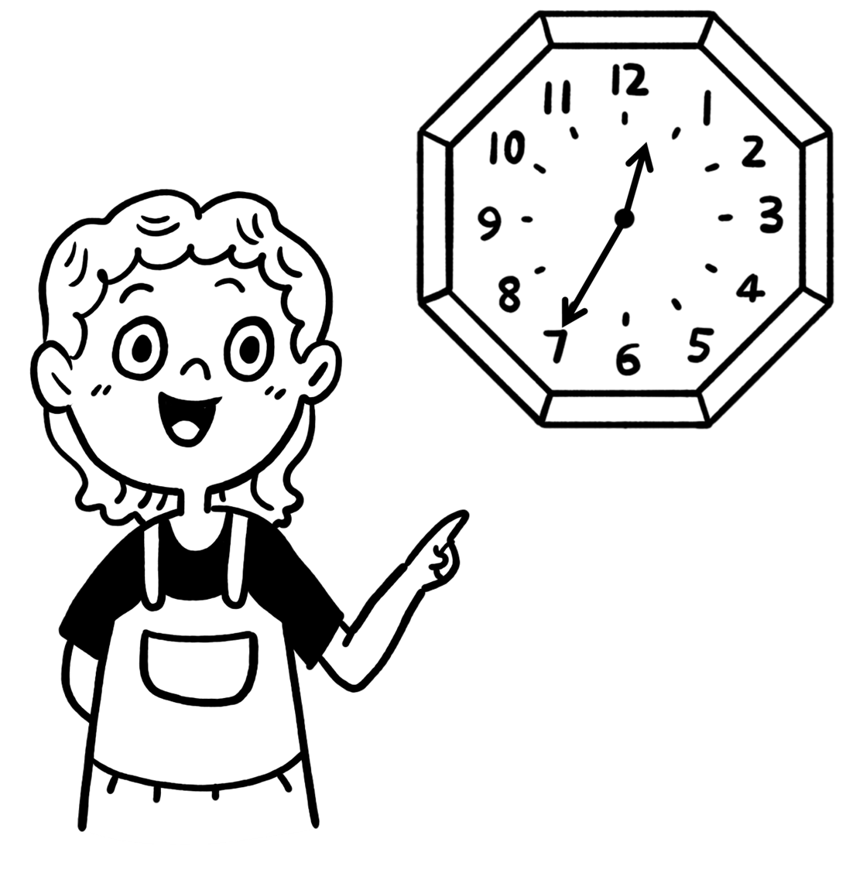
seven / twelve / thirty-five / forty-five
A: What time is it?
B: It’s .

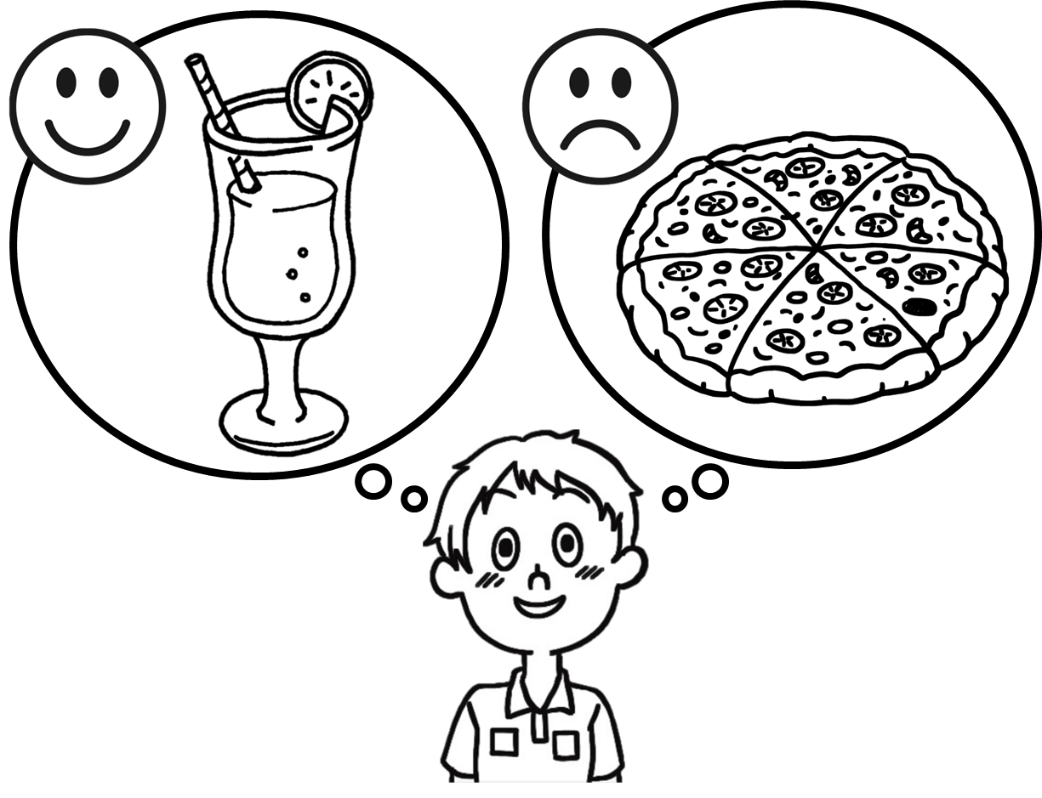
milk / water / pizza / juice
A: Do you like ?
B: No, I don’t.
But I like .
- 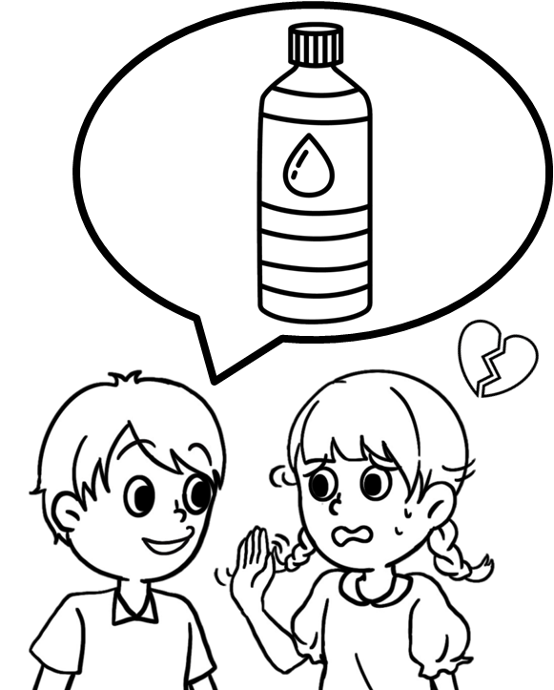
do / don’t / water / milk
A: Do you like ?
B: No, I 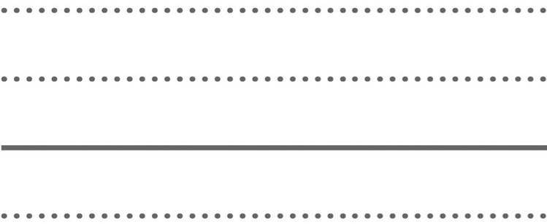.

- 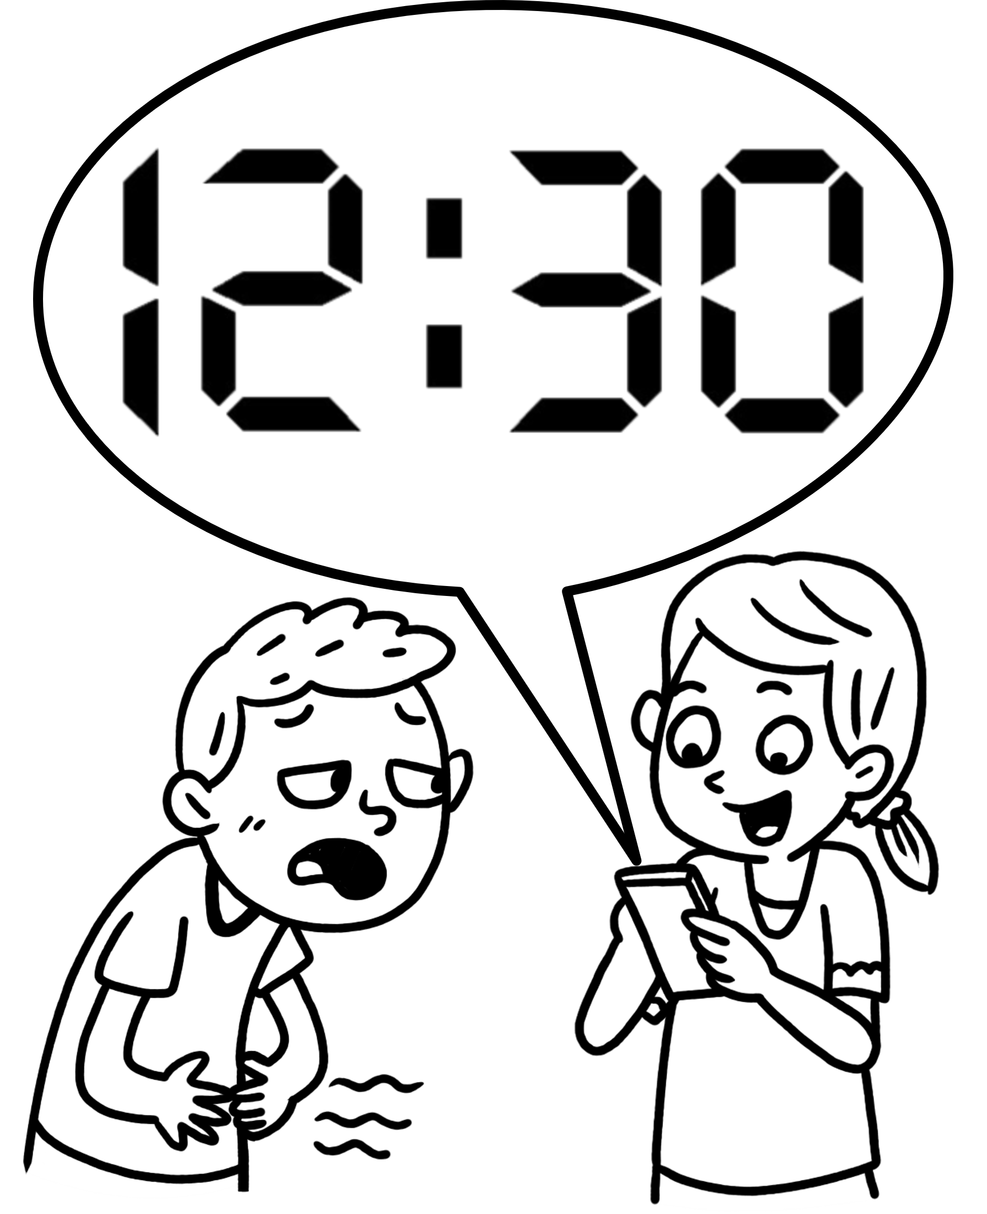
What / What’s / twenty / thirty
A: time is it?
B: It’s twelve .

- 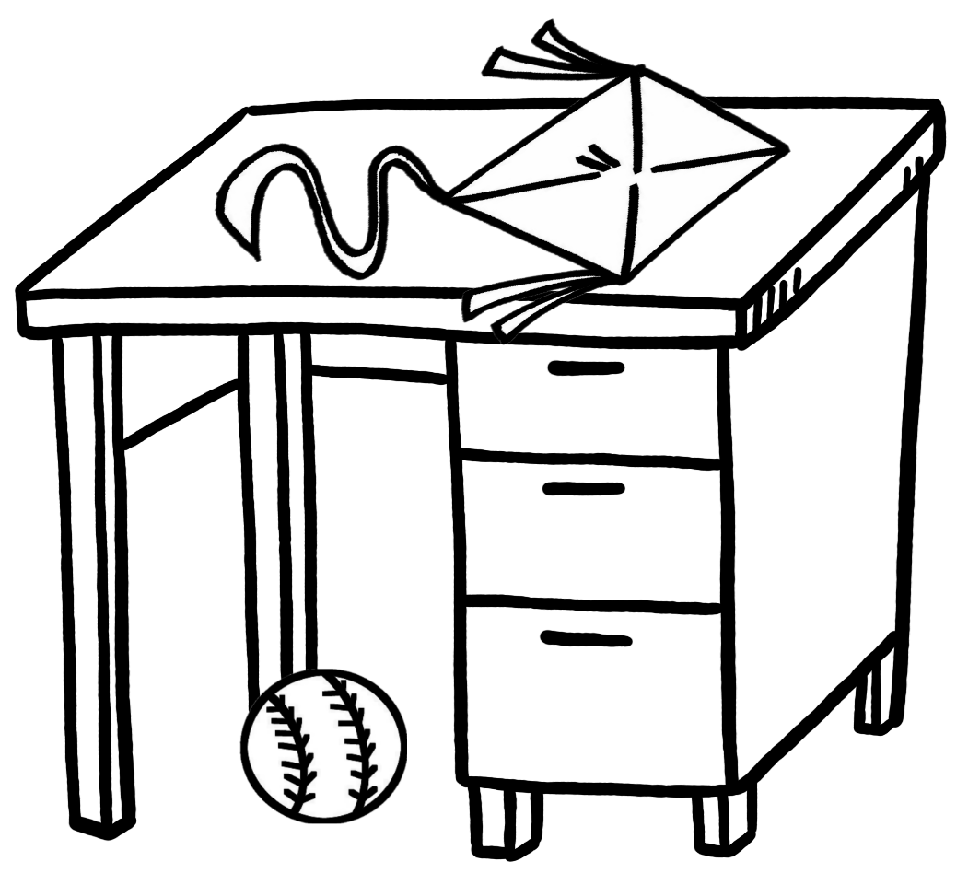
ball / box / desk / kite
A: Where’s the ?
B: It’s on the .

- 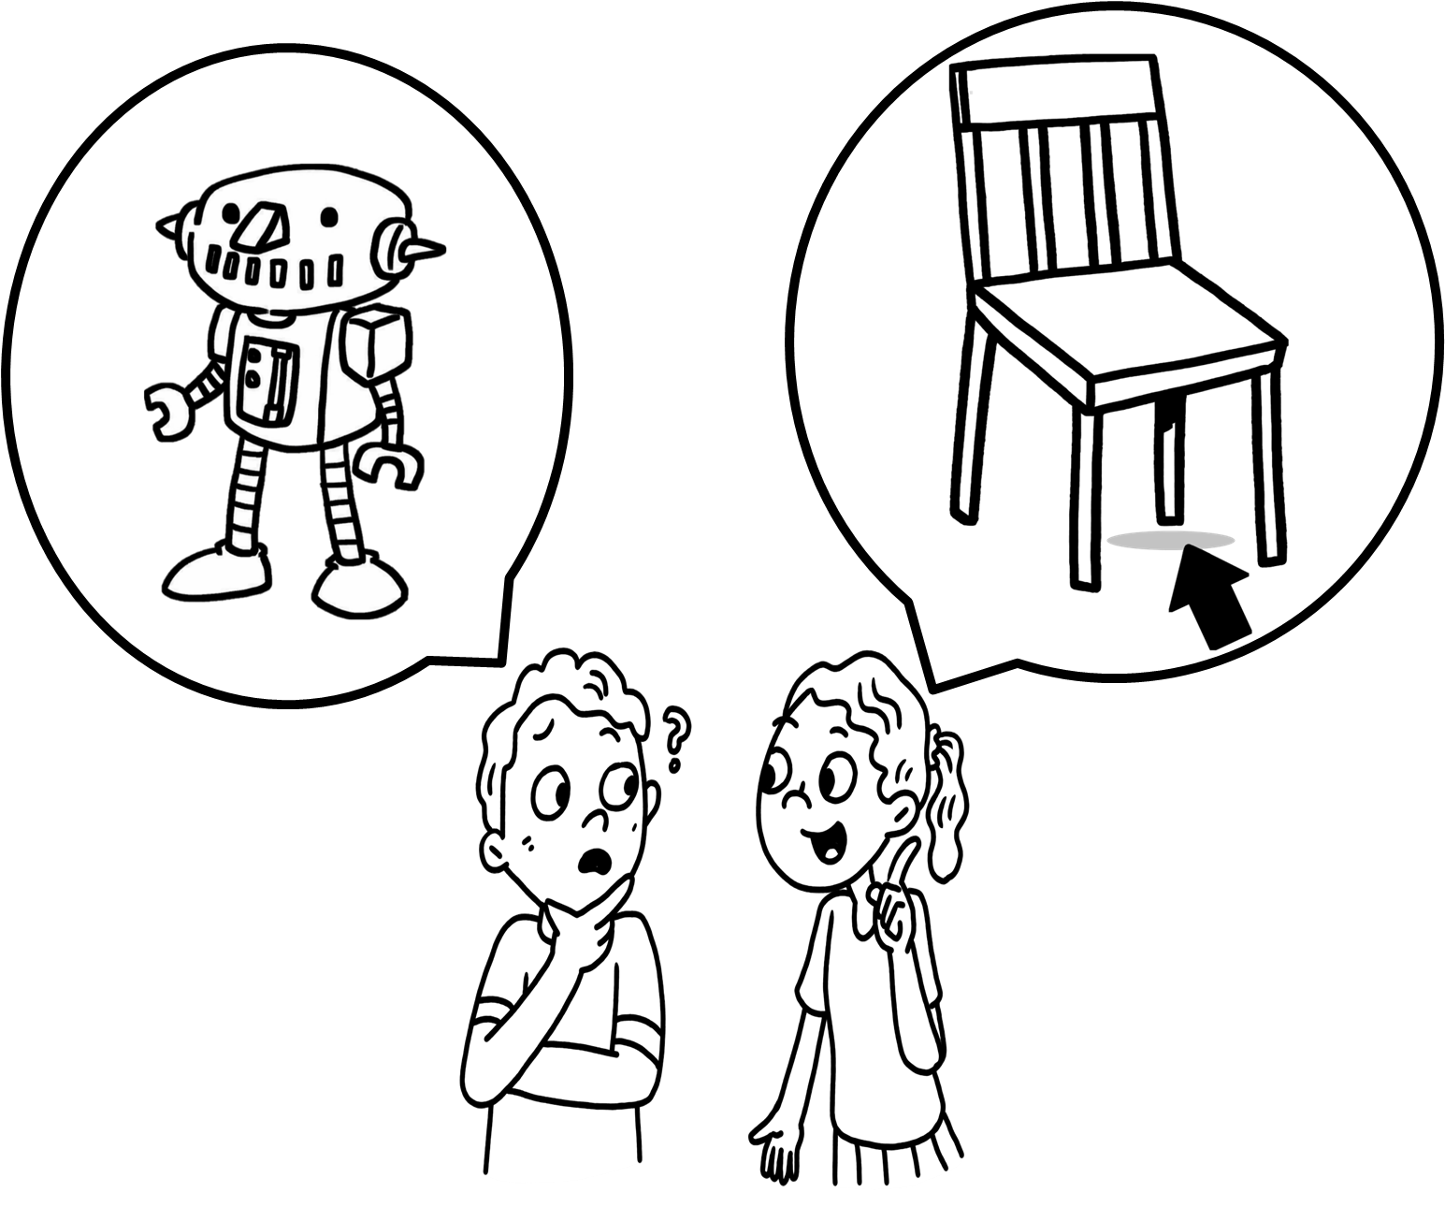
It’s / They’re / is / are
A: Where the robot?
B: under the chair.

- 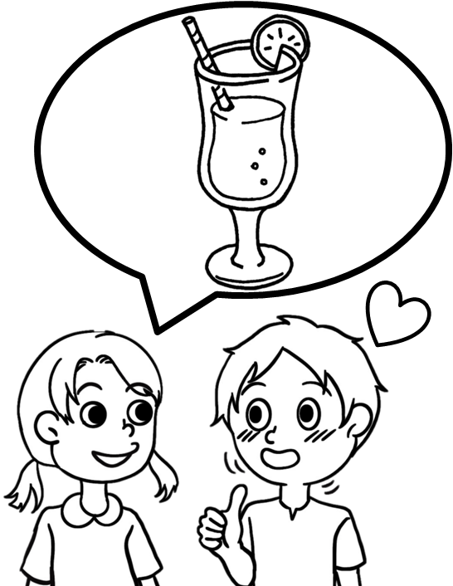
Yes / No / juice / pizza
A: Do you like ?
B: , I do.

- 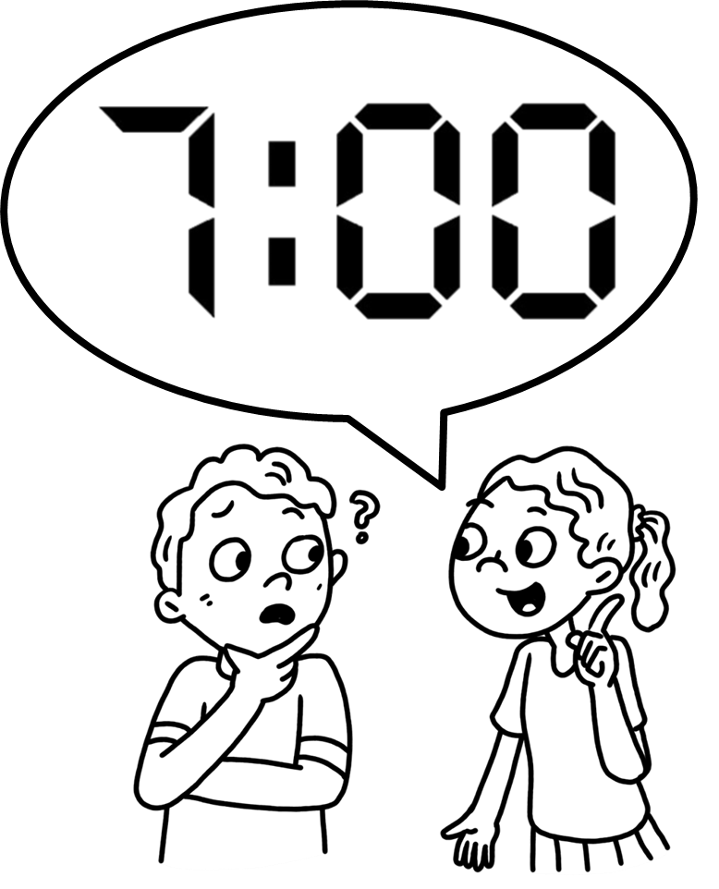
color / time / forty / o’clock
A: What is it?
B: It’s seven .

- 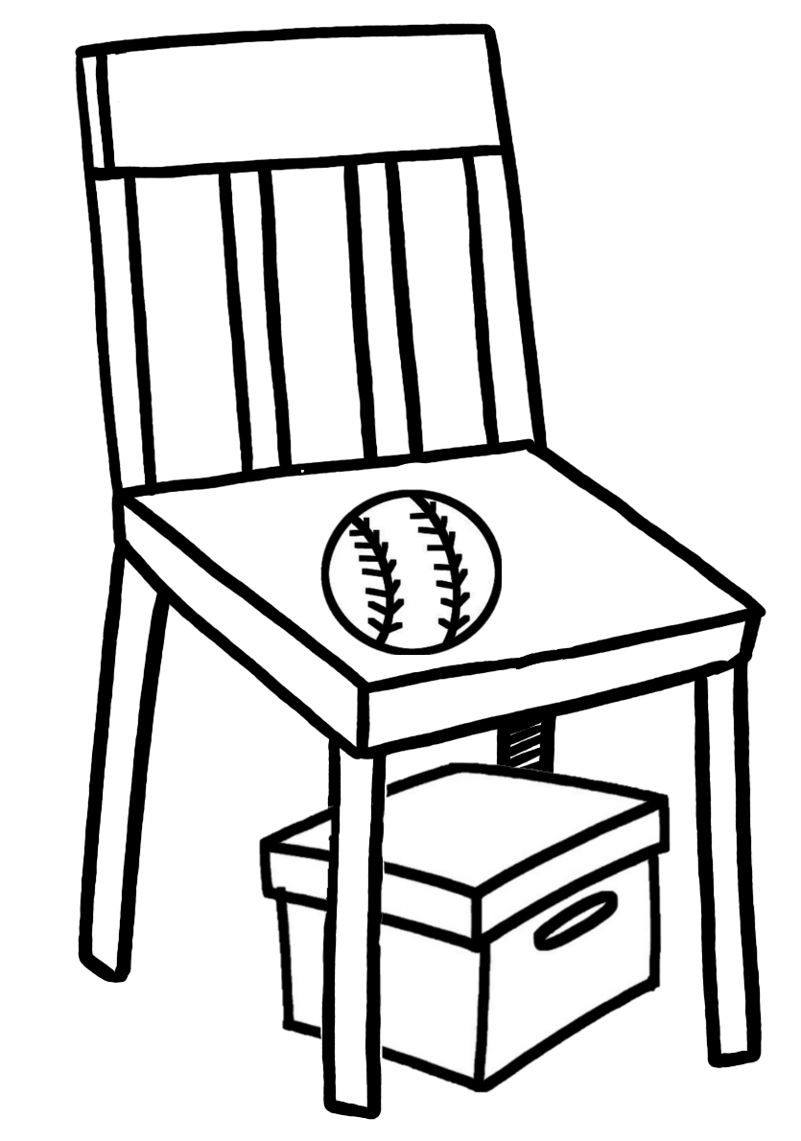
on / under / chair / desk
A: Where’s the ball?
B: It’s the .

- 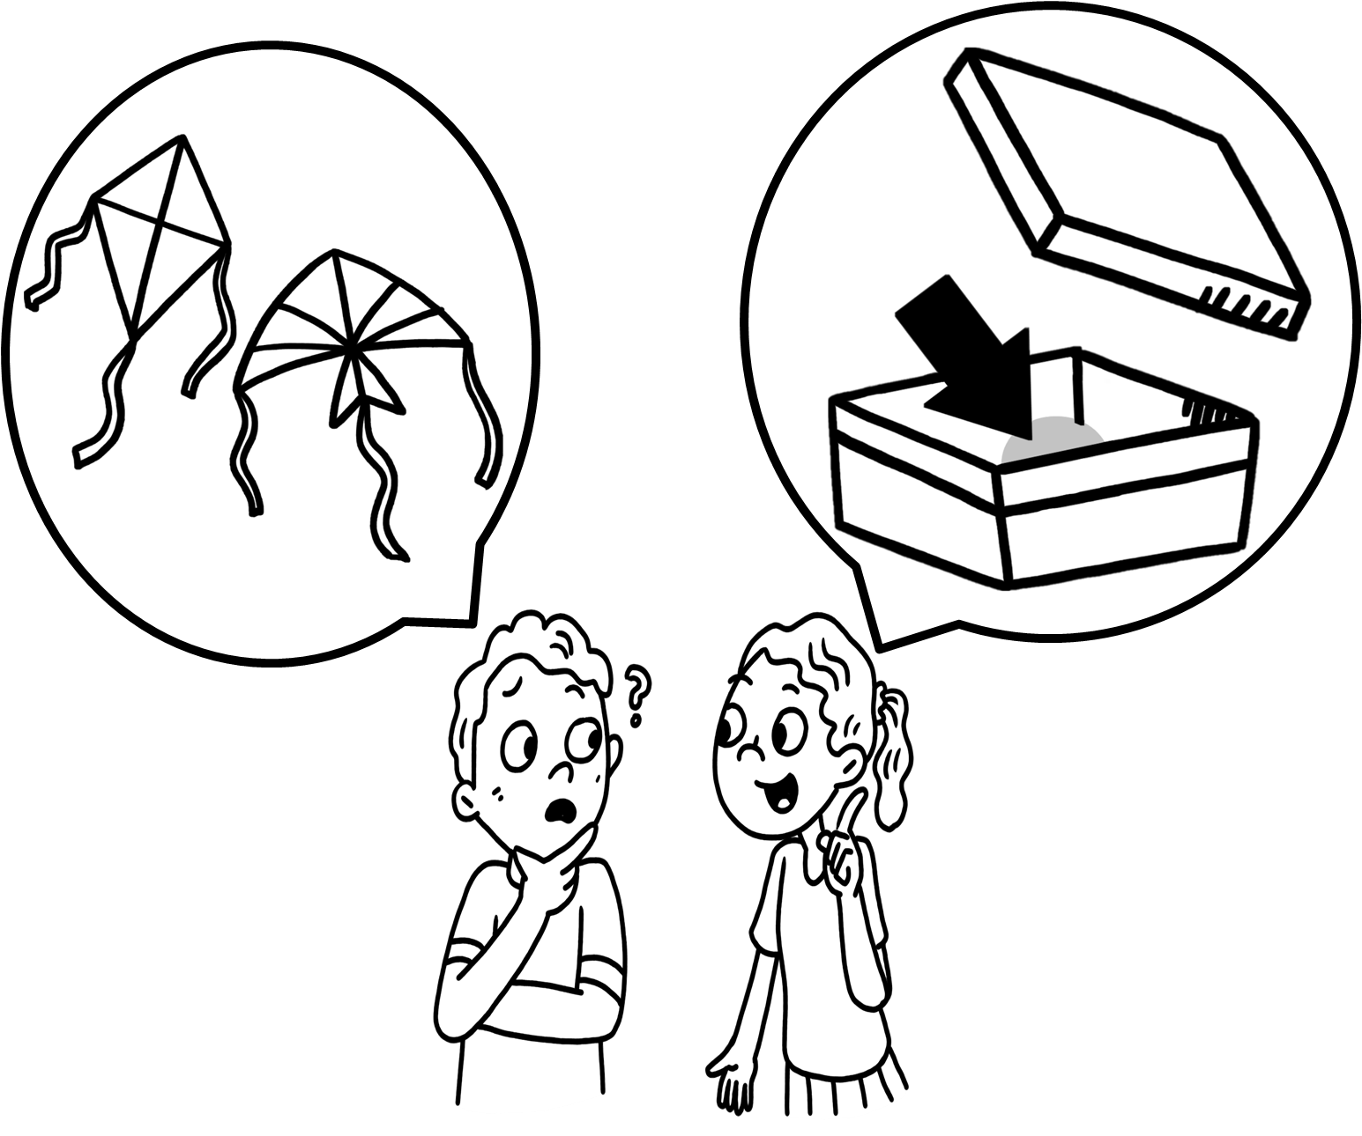
in / on / bag / box
A: Where are the kites?
B: They’re the .

- 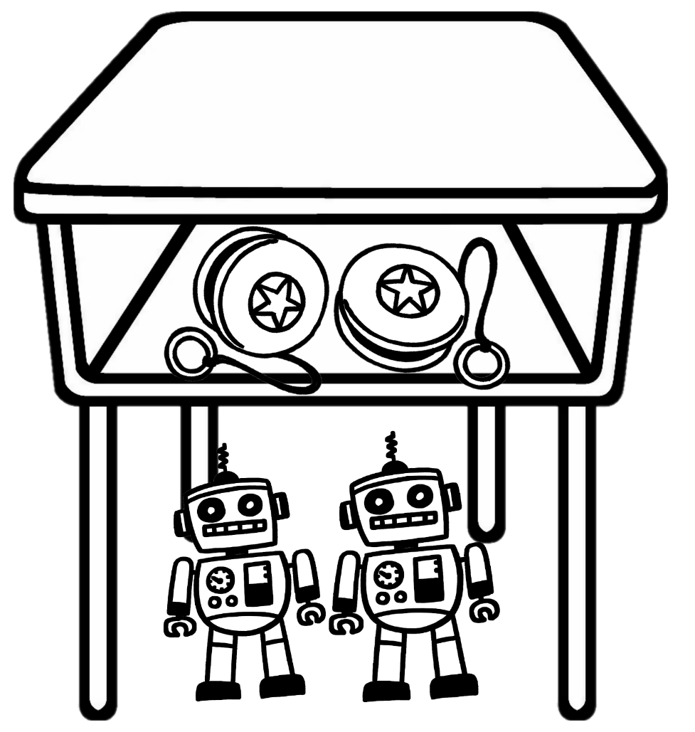
in / under / desk / chair
A: Where are the yo-yos?
B: They’re the .

